1) Checkbox not clearly visible
Description-
In Tariff management,TAC Exceptions Checkbox not clearly visible
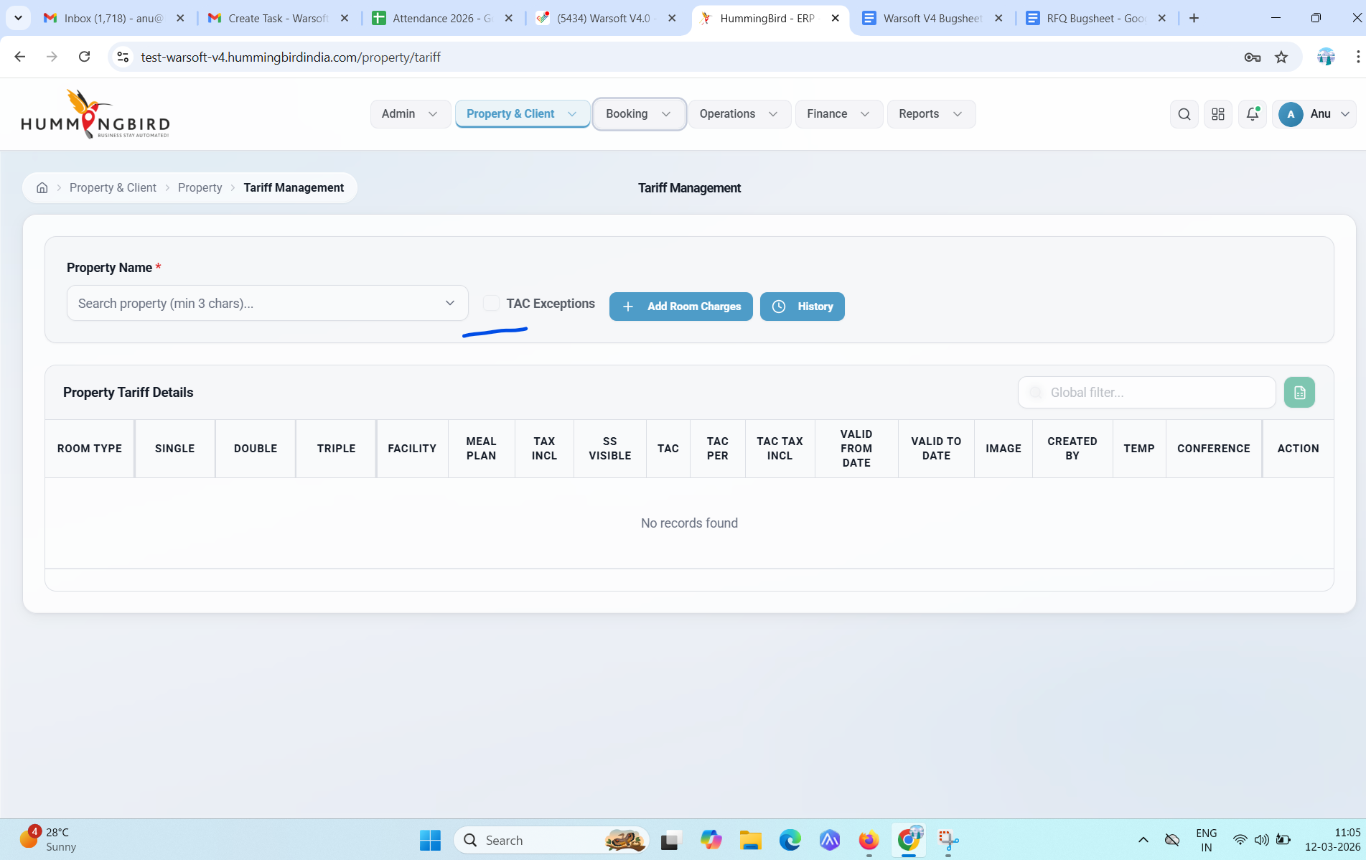

2) Control initial space in filter
Description-
Control initial space in all filters
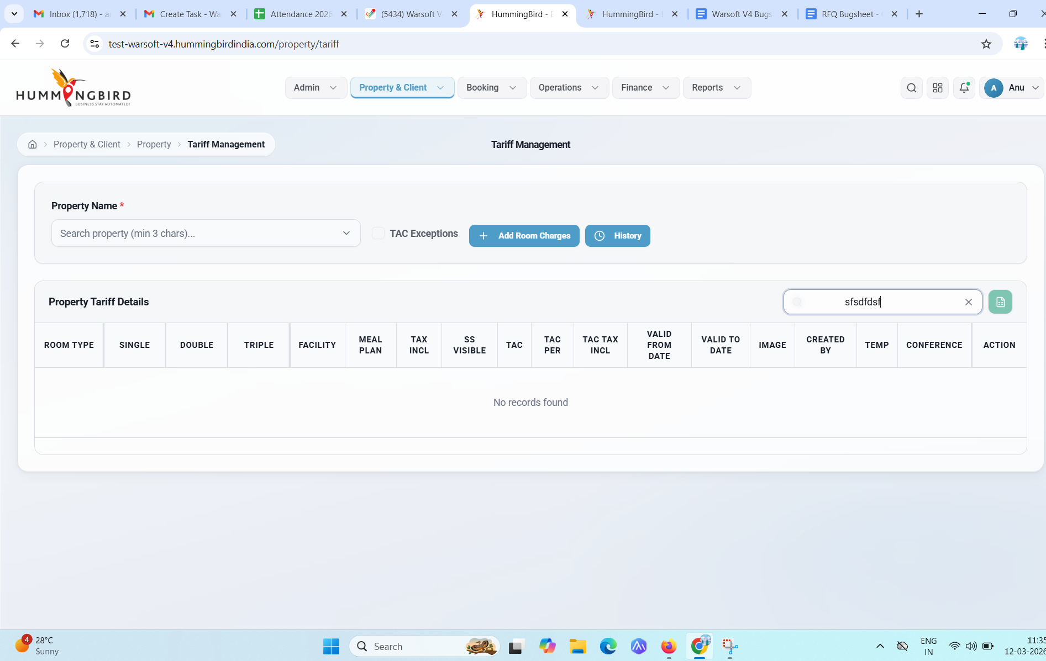

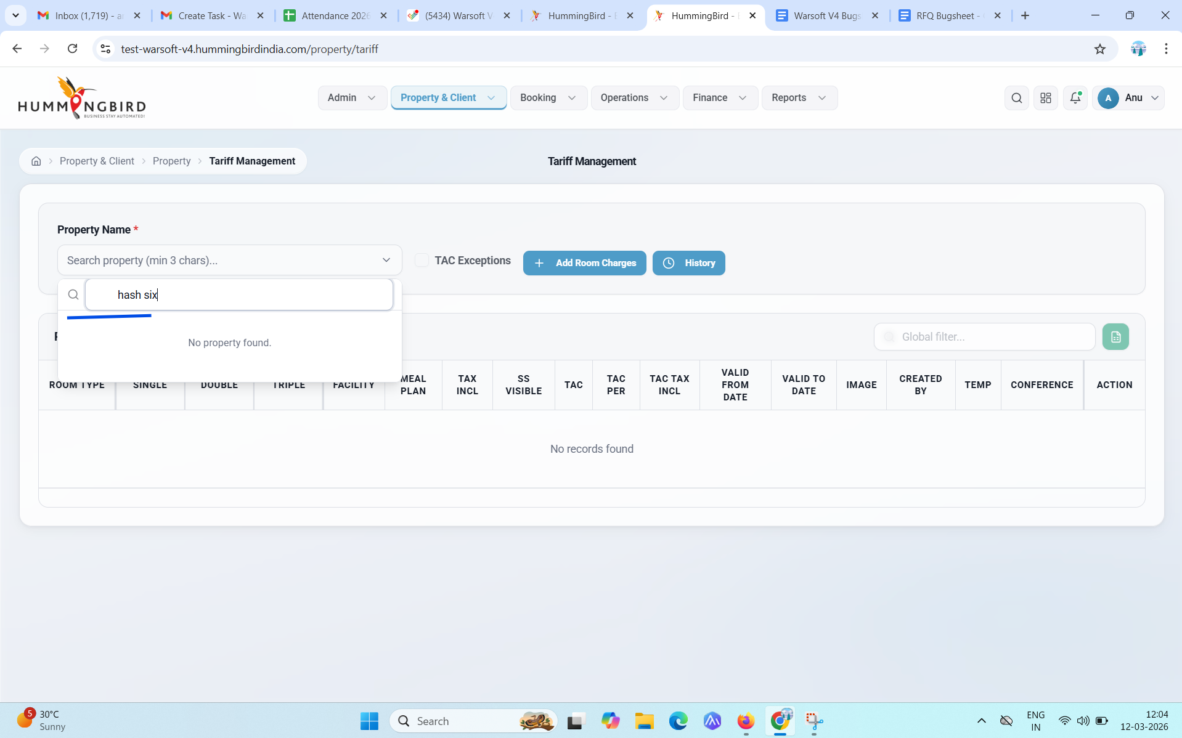

Bugsheet 2 3/4/26
In History page
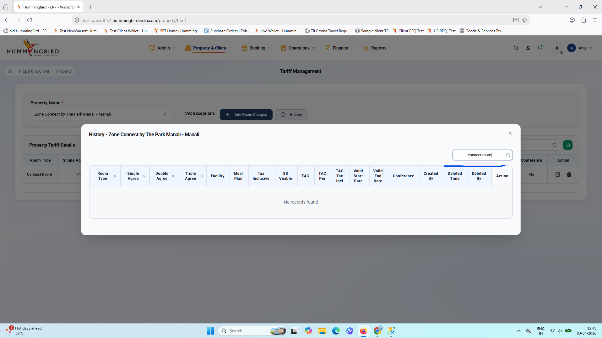

3) Table header name is in caps
Description-
All table header name is in caps for this screen
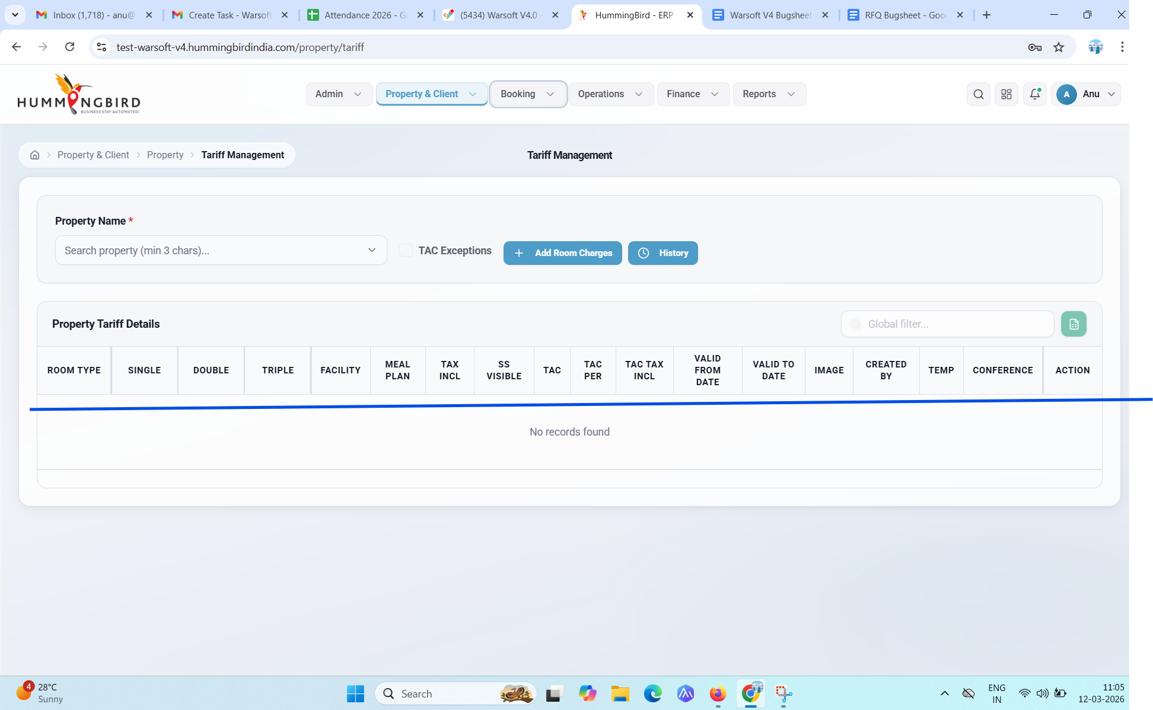

4) Table heading name difference
Description-
In new site, the marked Table header name is mismatch from old site
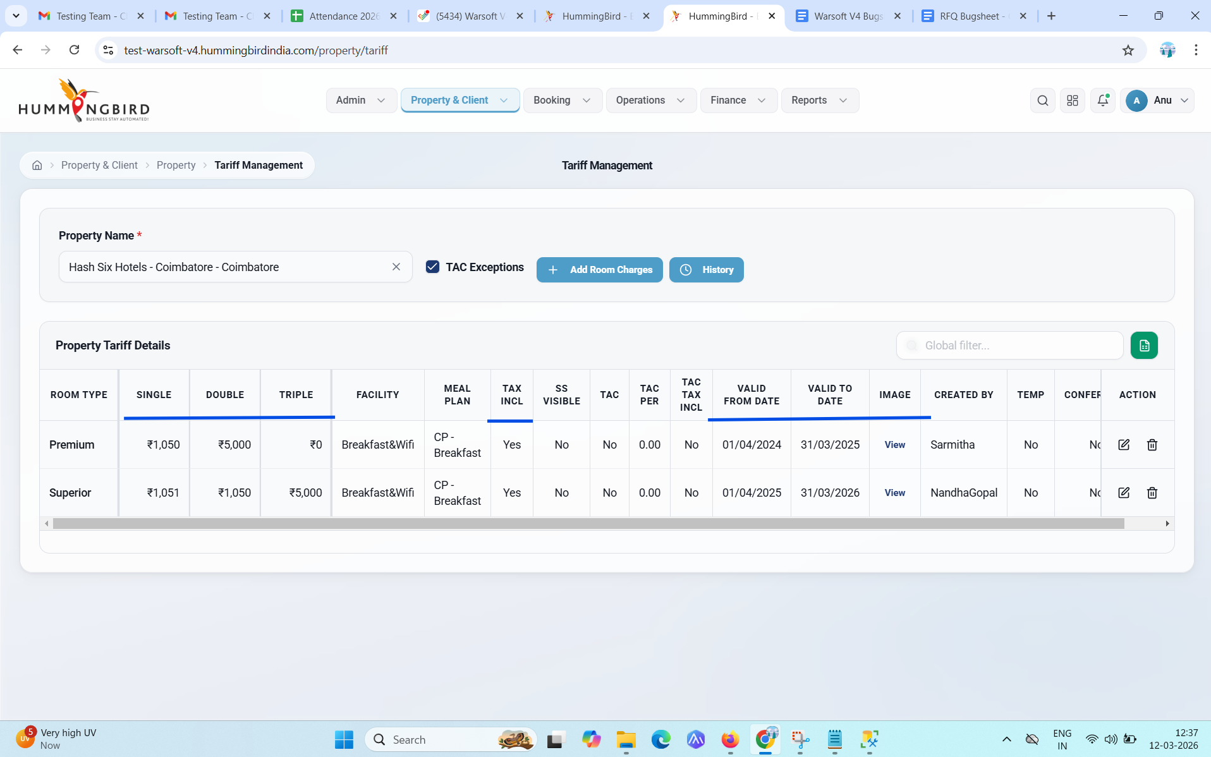
History
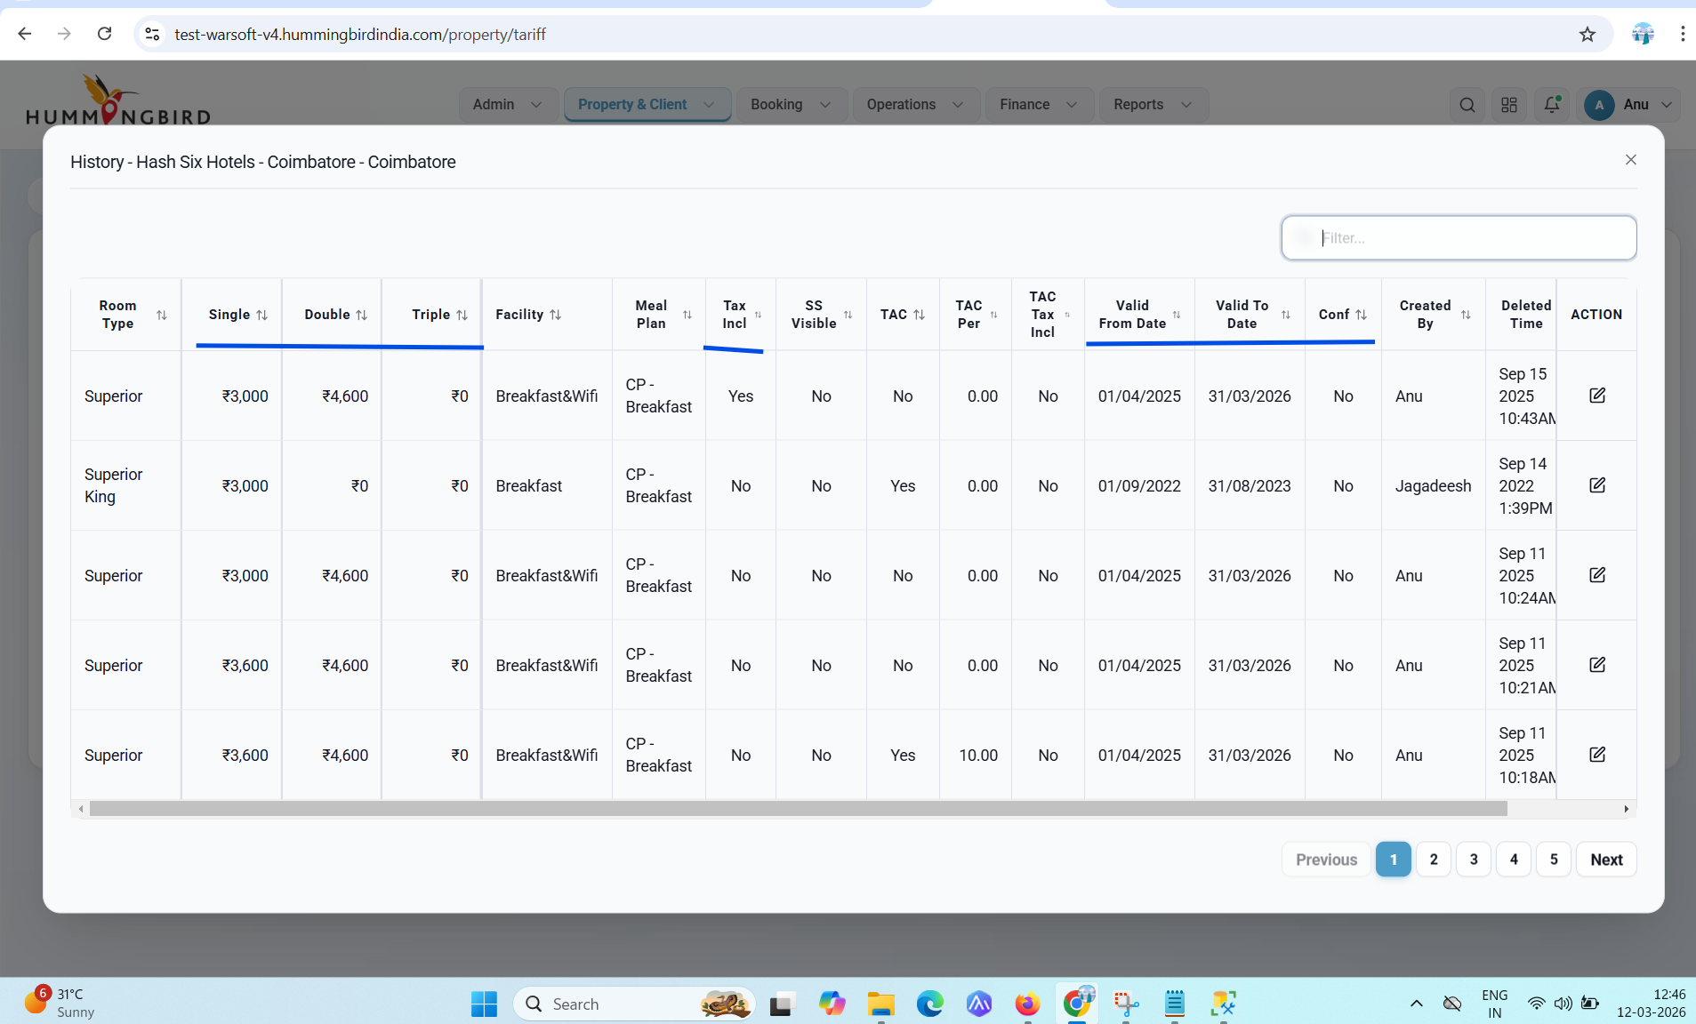

Old tariff management screen for reference
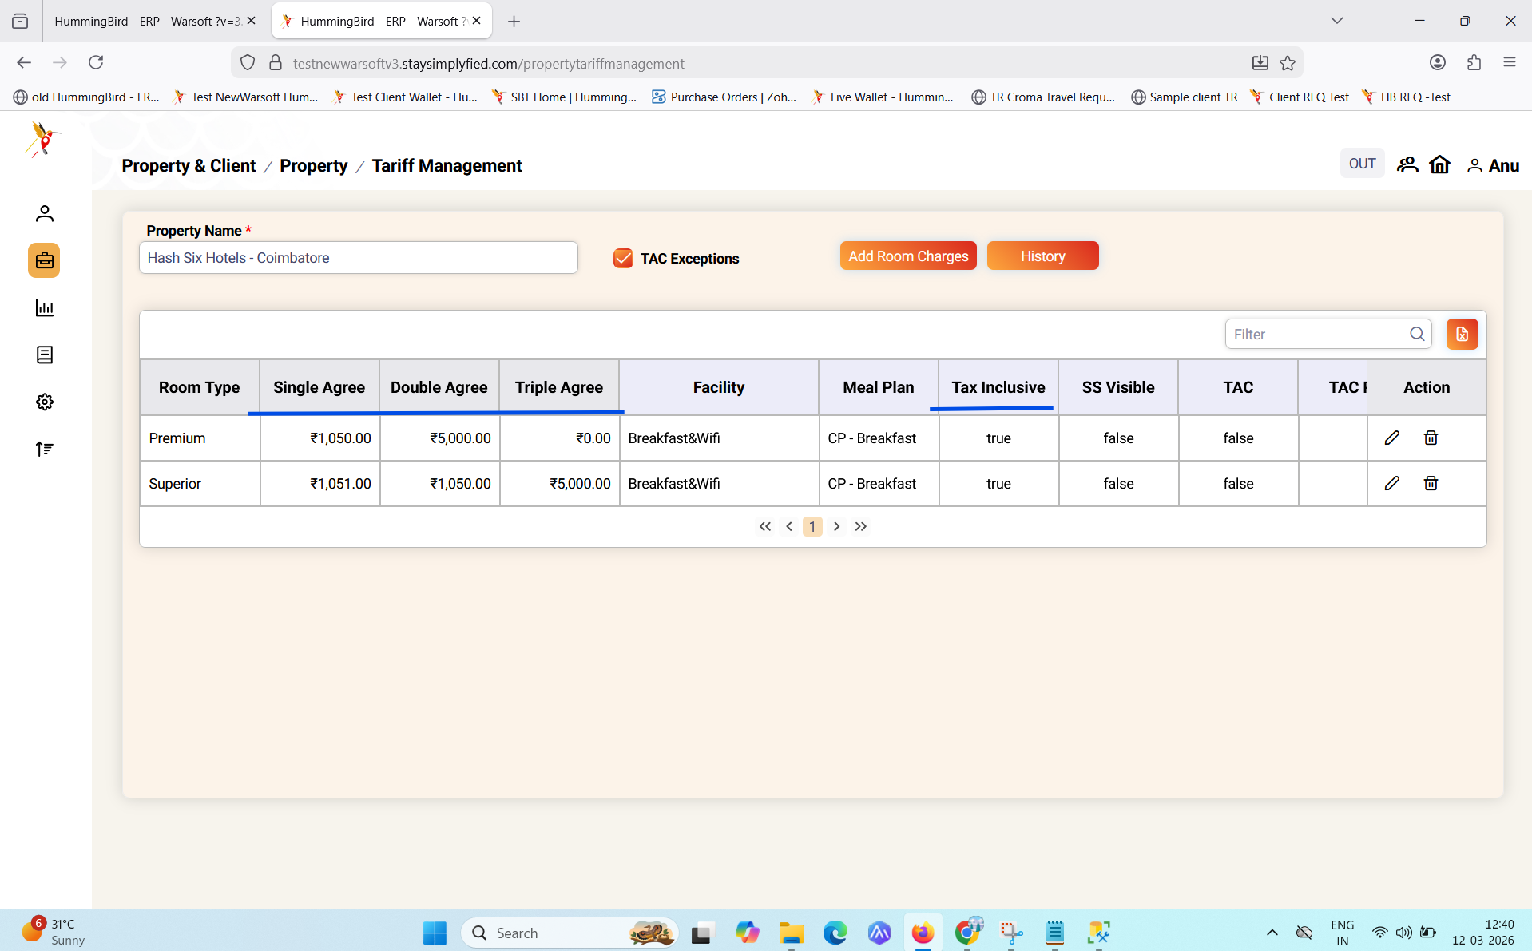

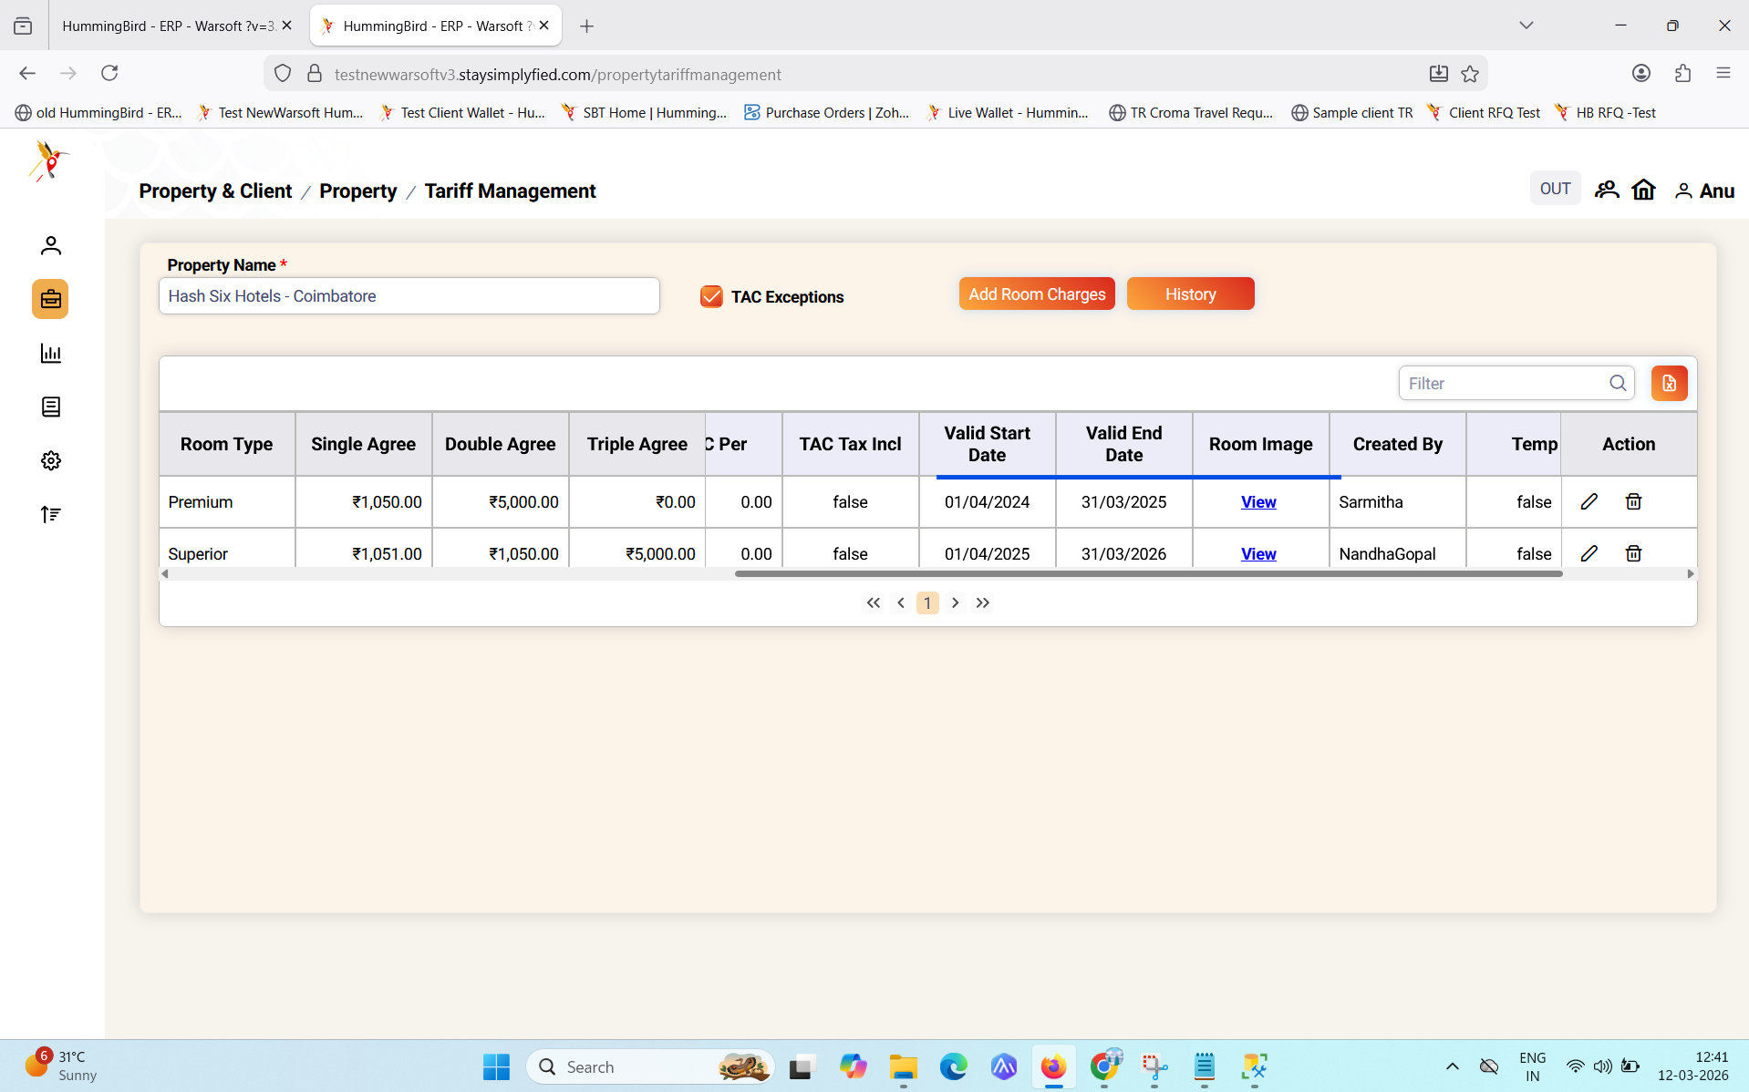

5) Tool tip data not showing
Description-
Existing room type is tax inclusive ‘tool tip’ is not showing
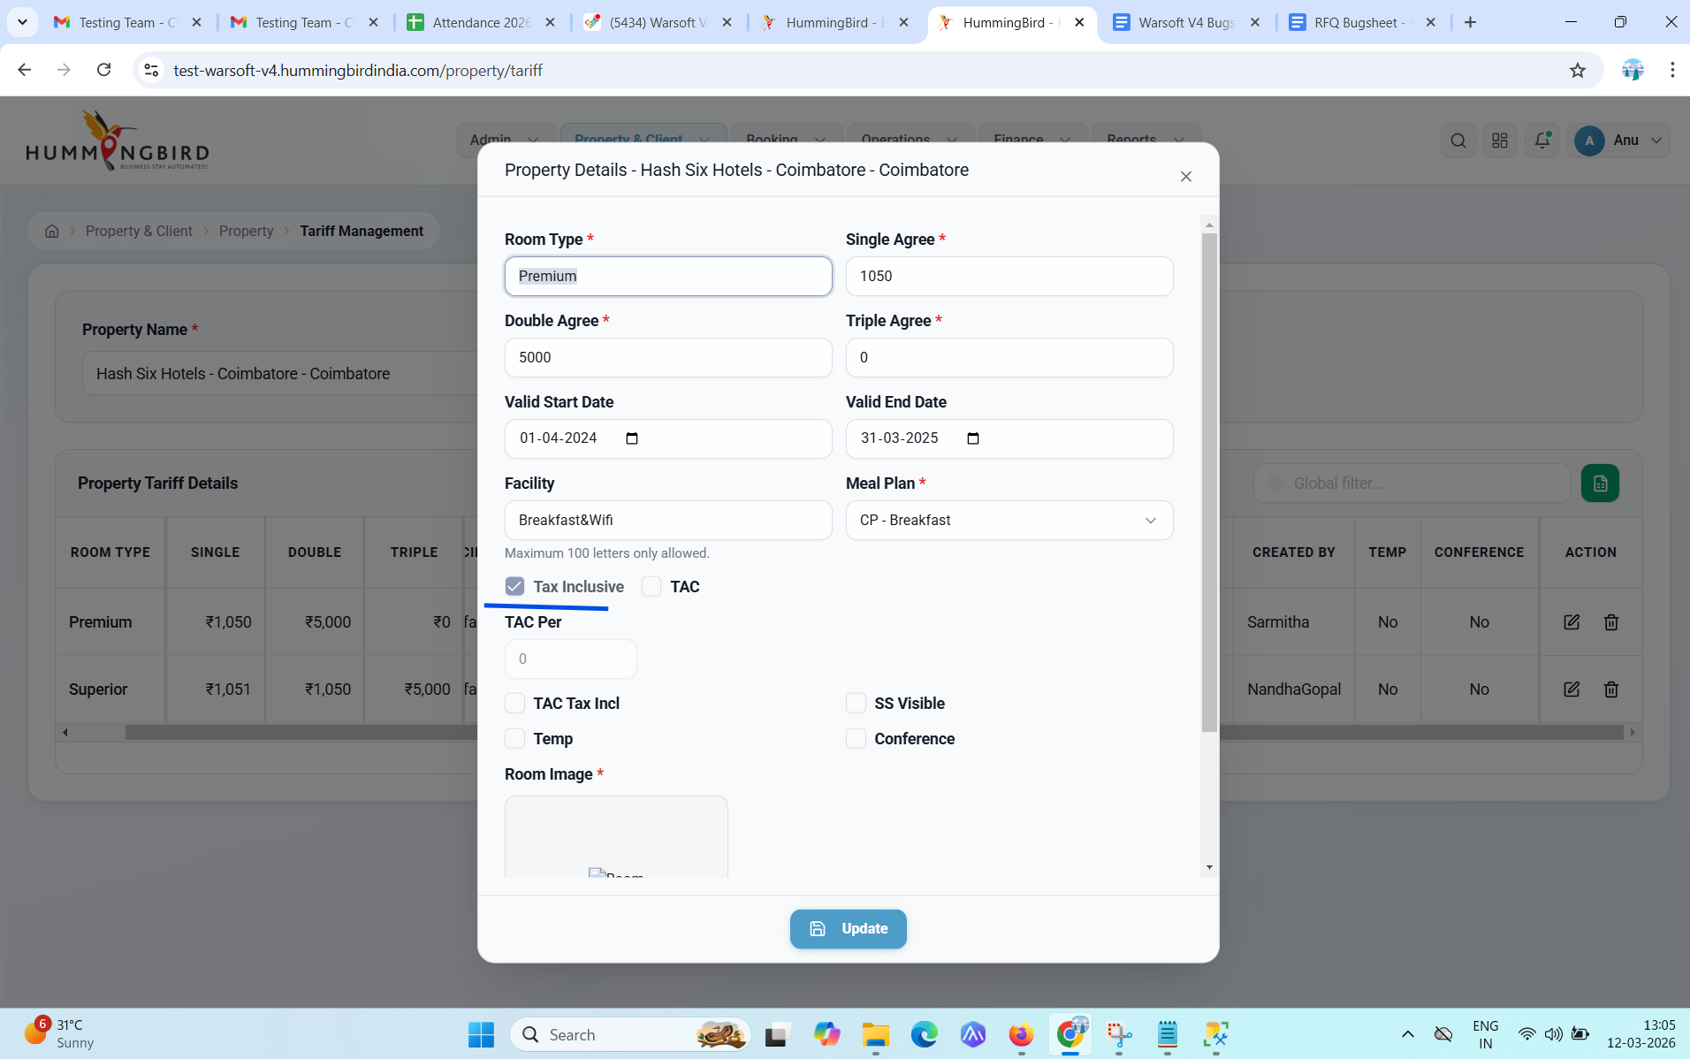

Old tariff management screen for reference

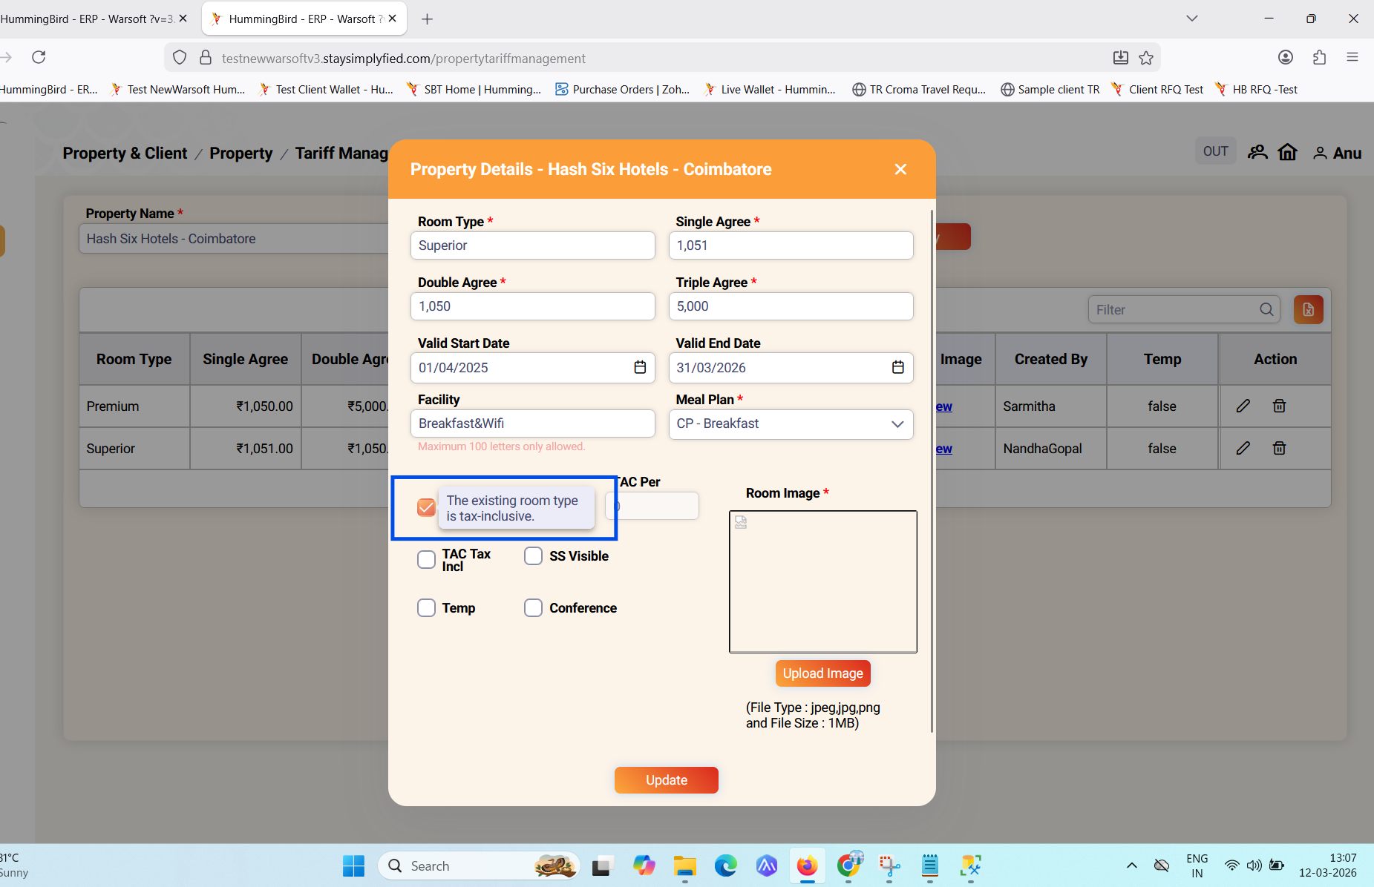

6) Design issue at background
Description-
Design issue at background when clicking ‘Add room charges’ and ‘Room Details’ popup appears.
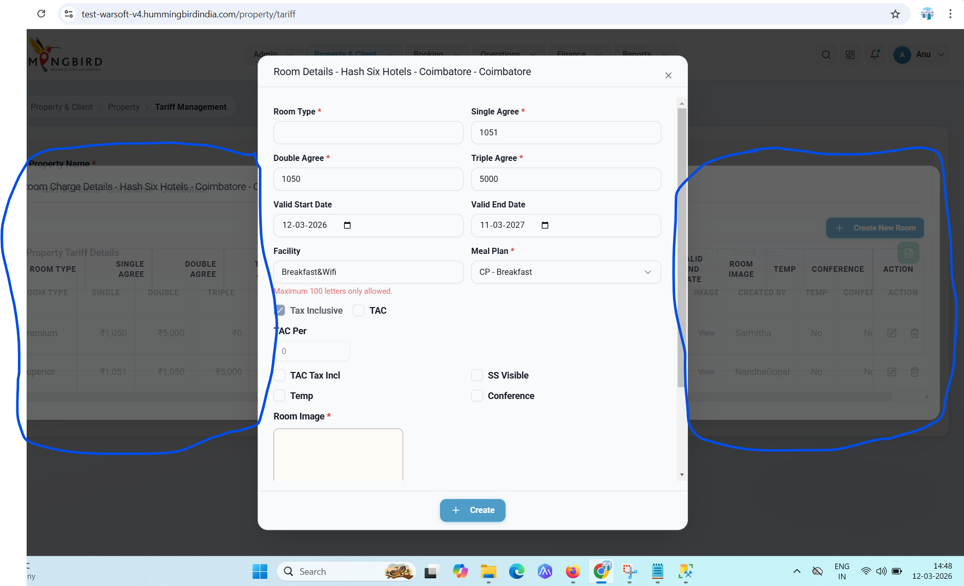

7) Error message content
Description-
When clicking ‘Add room charges’ and ‘Room Details’ popup appears.and clicking on “create” button
Use Existing image from grid means? Where is the image available
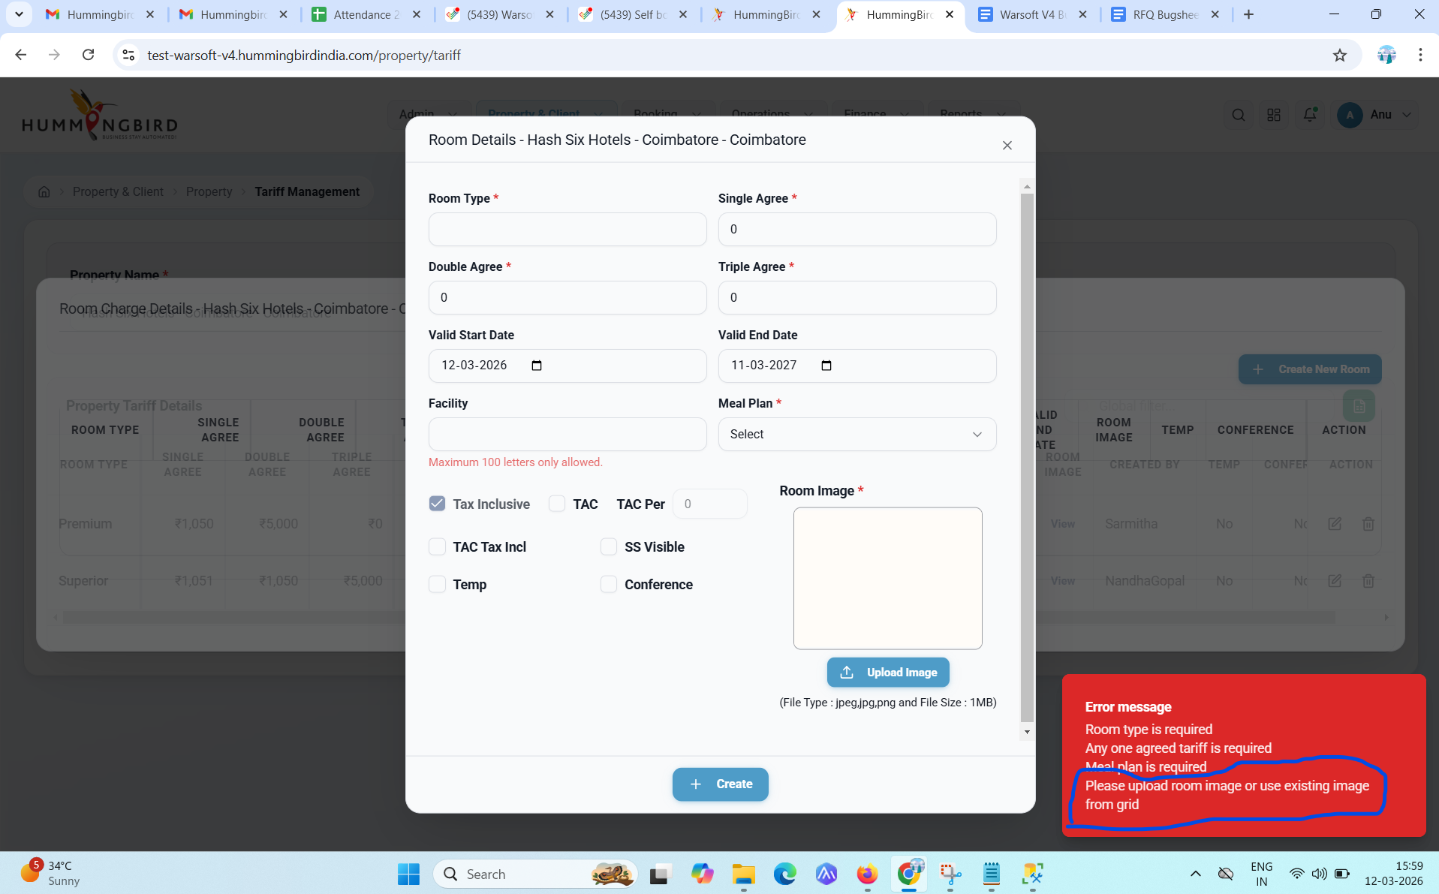

8) Date picker icon alignment
Description-
Date picker icon alignment is in center
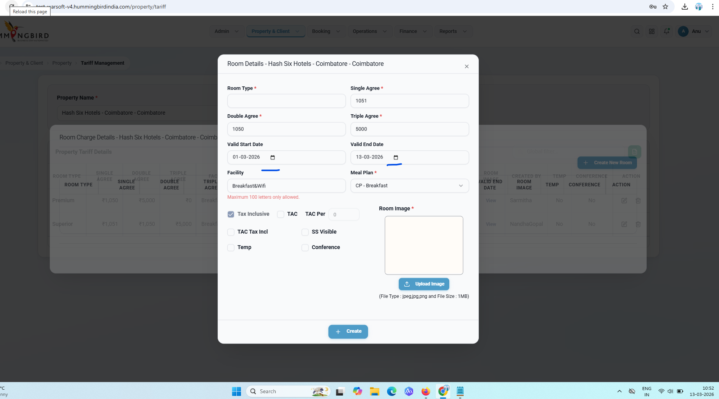

9) Room image upload size not fit to the box
Description-
Uploaded Room image - image not correctly fit to the mentioned Room image box
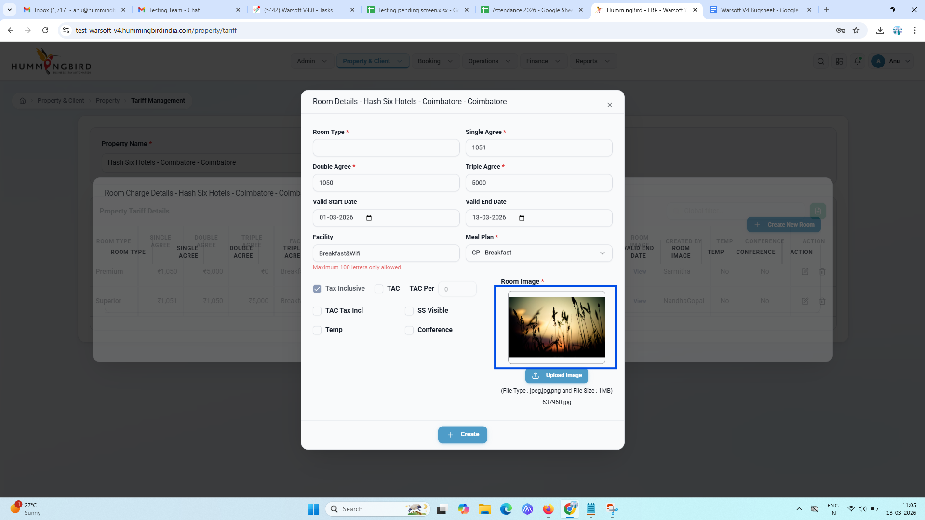

Reference

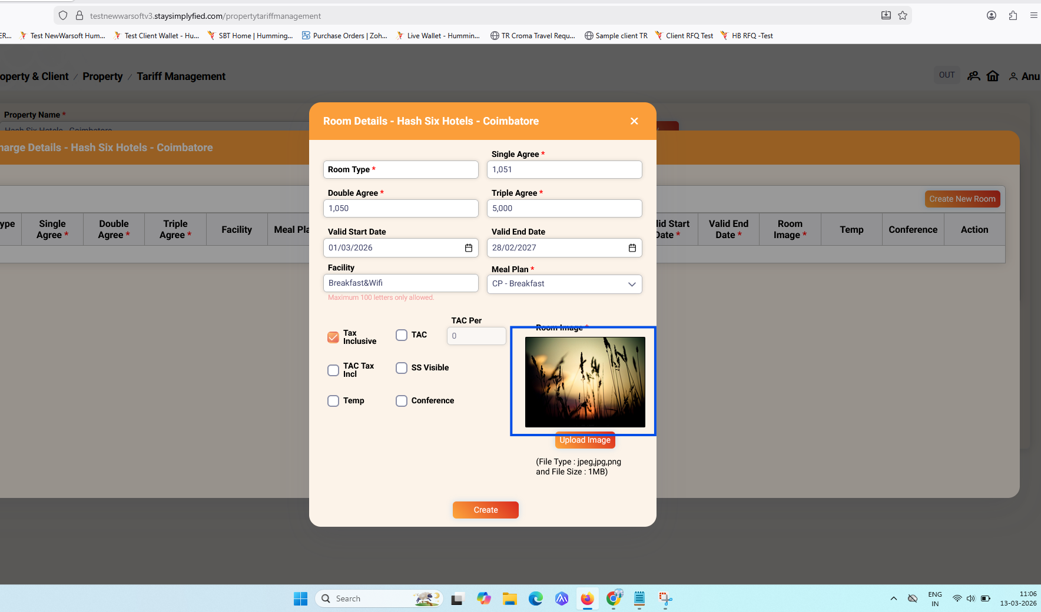
10) Alignment issue
Description-
Single ,double,triple agree alignment is not in center
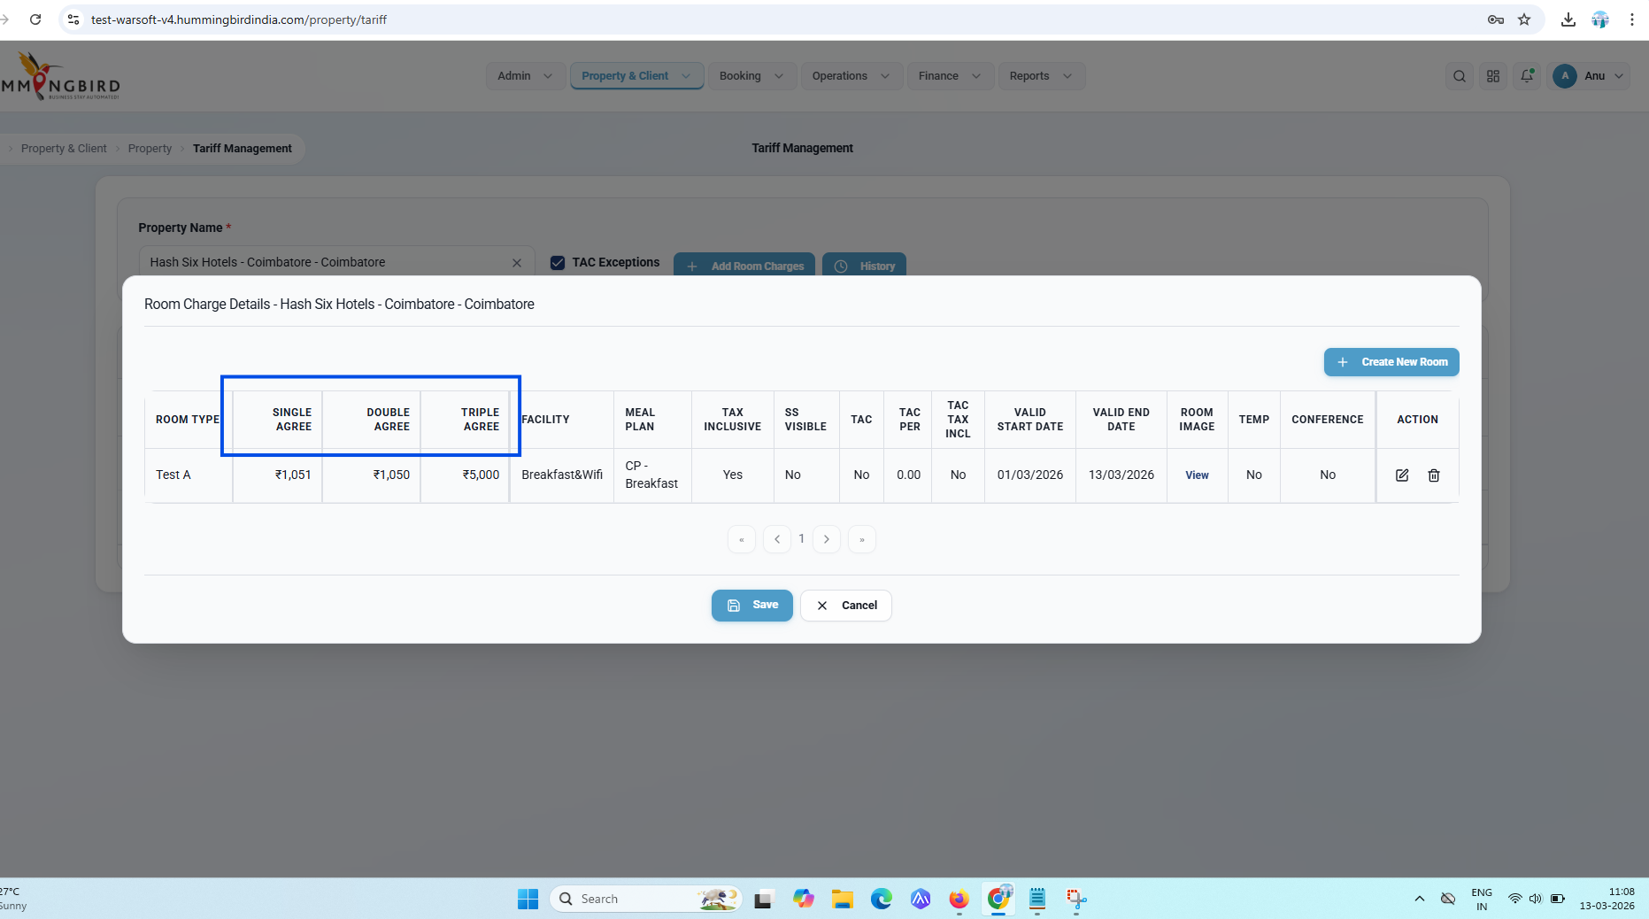

11) Tool tip not shown in Room charge details table
Description-
In Room charge details table - Tool tip not showing when mouse hover to Edit and delete icon
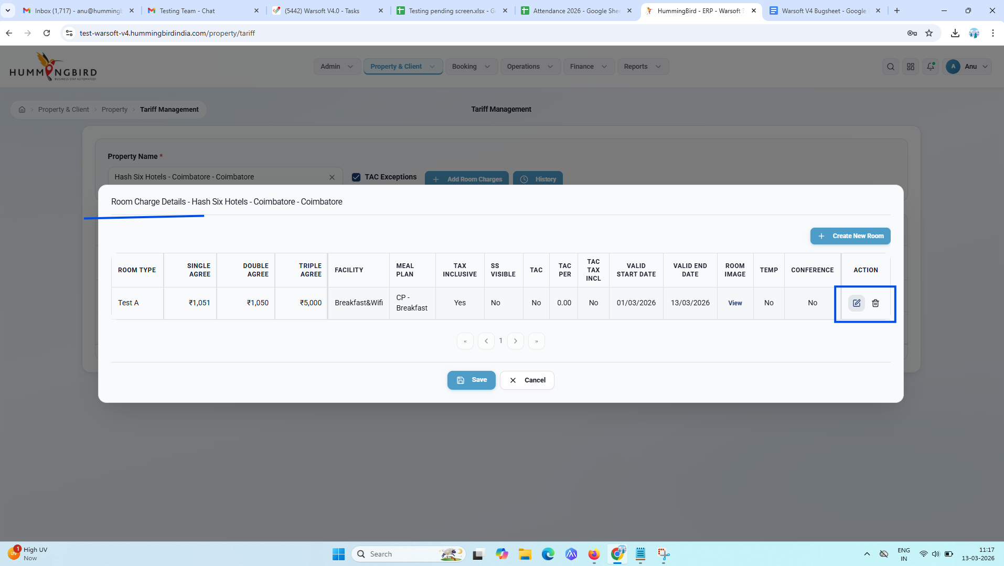
12) To Date captured wrongly in screen
Description-
Selected Valid End Date in screen is 13/03/2026
In Database the ”ToDate” date updated correctly as ‘13/03/2026’
But in ‘Property Tariff Details’ showing normal 1 year from the selected from date ‘28/02/2027’
Room id - “387445”
Video attached in the attachments
Tariff Management 12 - warsoftv4
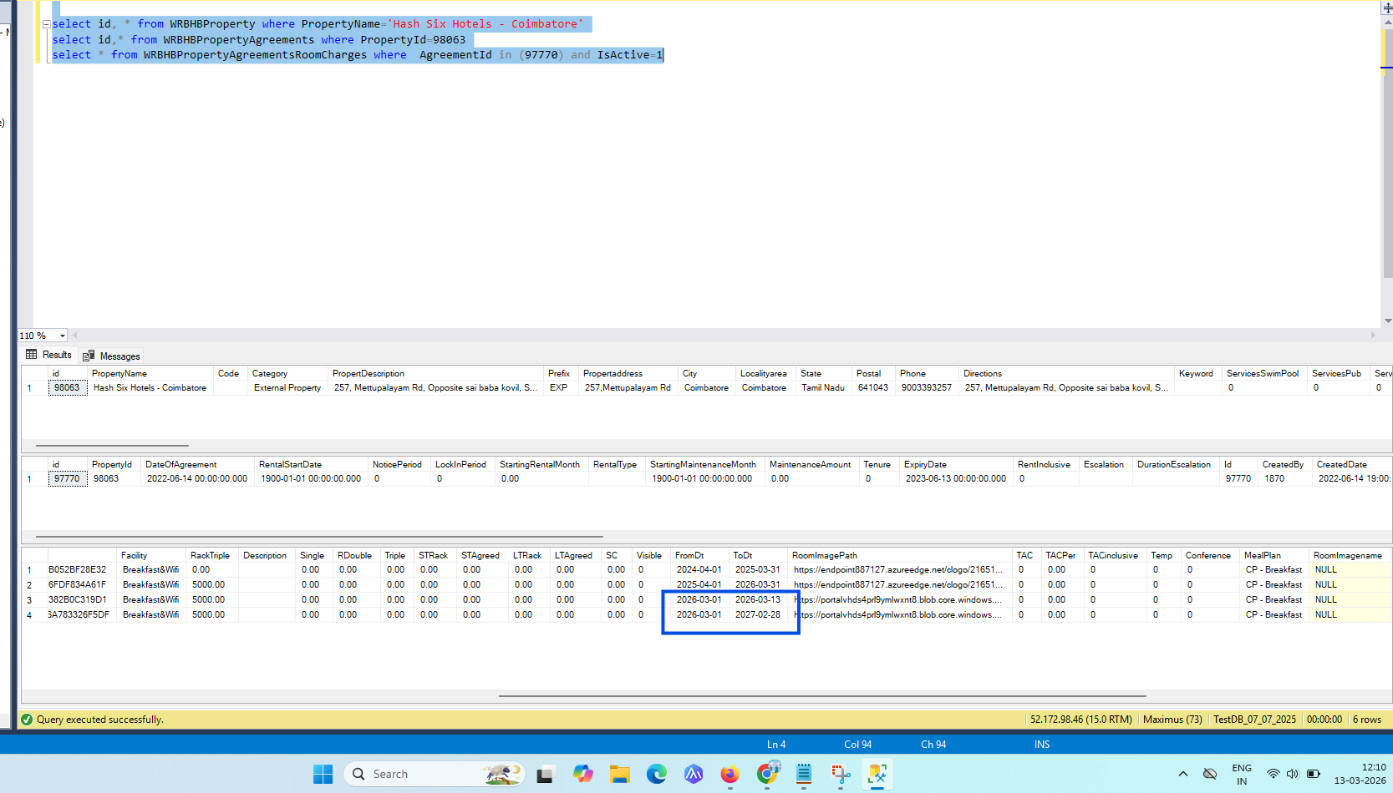

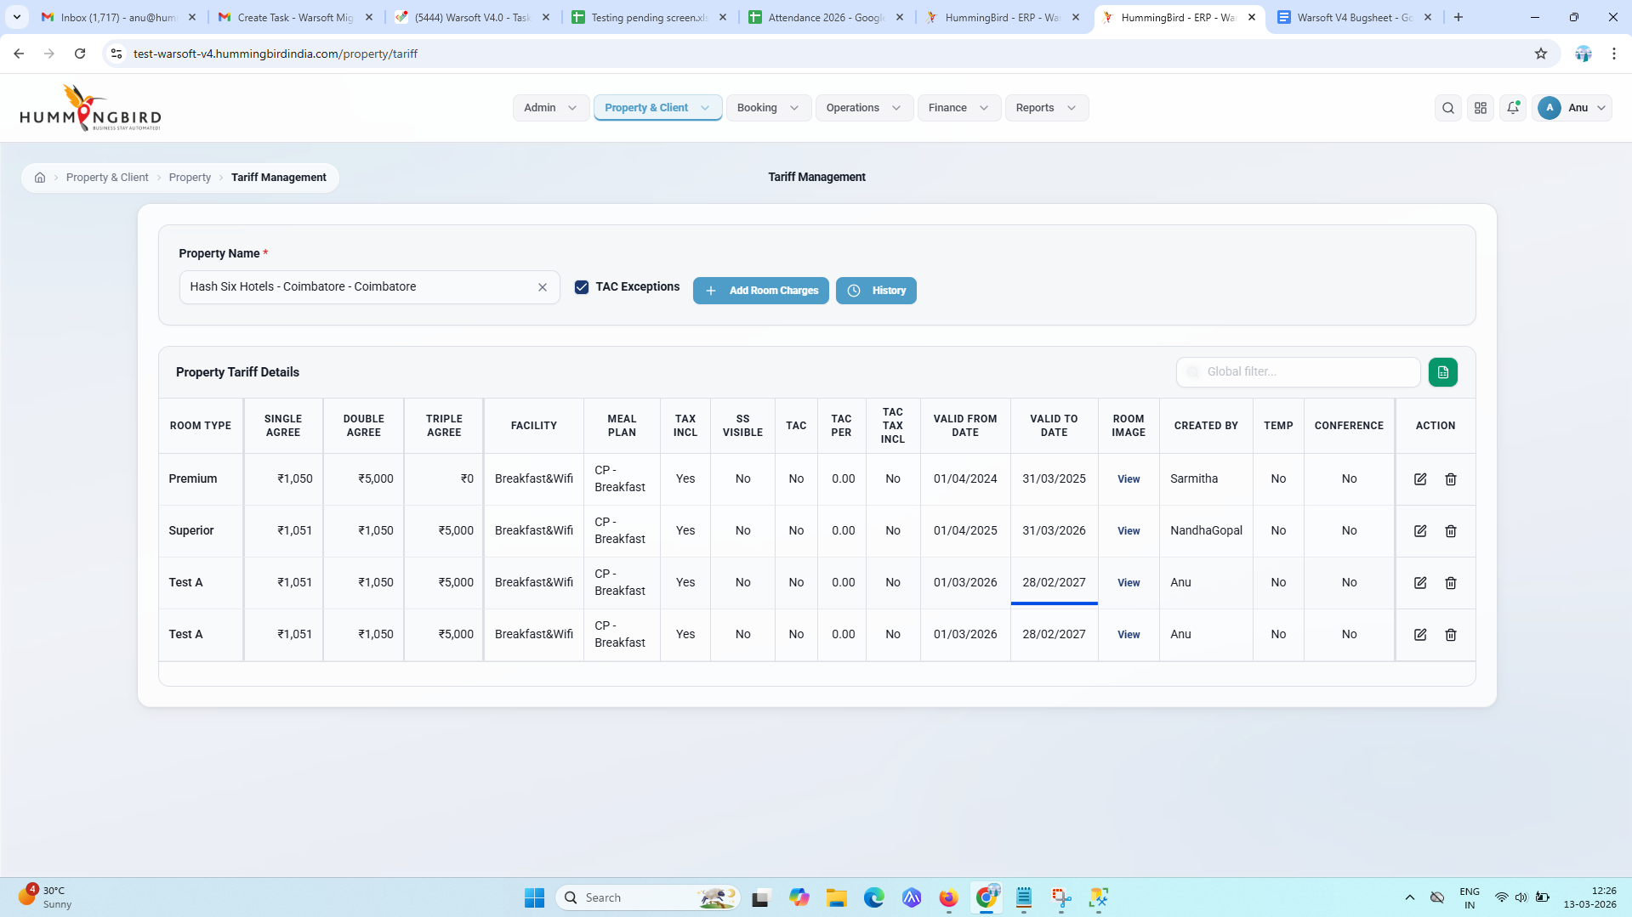

13) Tariff fields amount able to enter more
Description-
Tariffs length is more need to control the length
Rate Tariff validation is not checked
Entering amount with countless allowing more length.
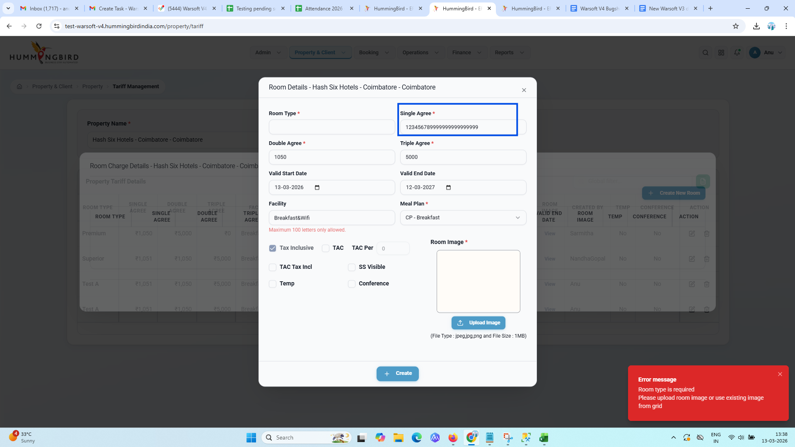

Reference

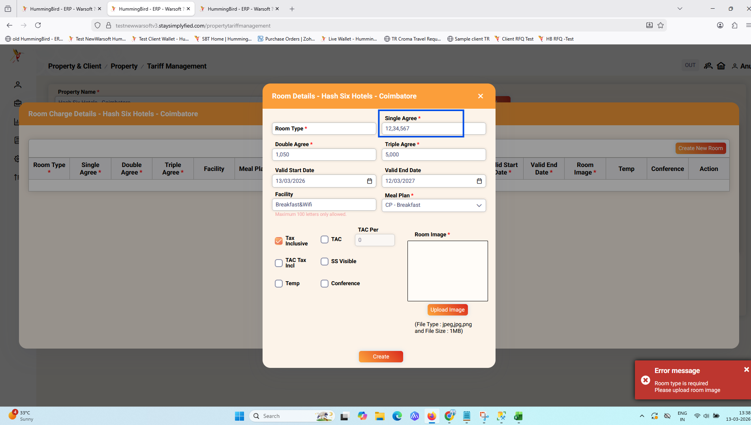

14) Remove pagination in Room charge Details
Description-
Room charge details table - Pagination not need
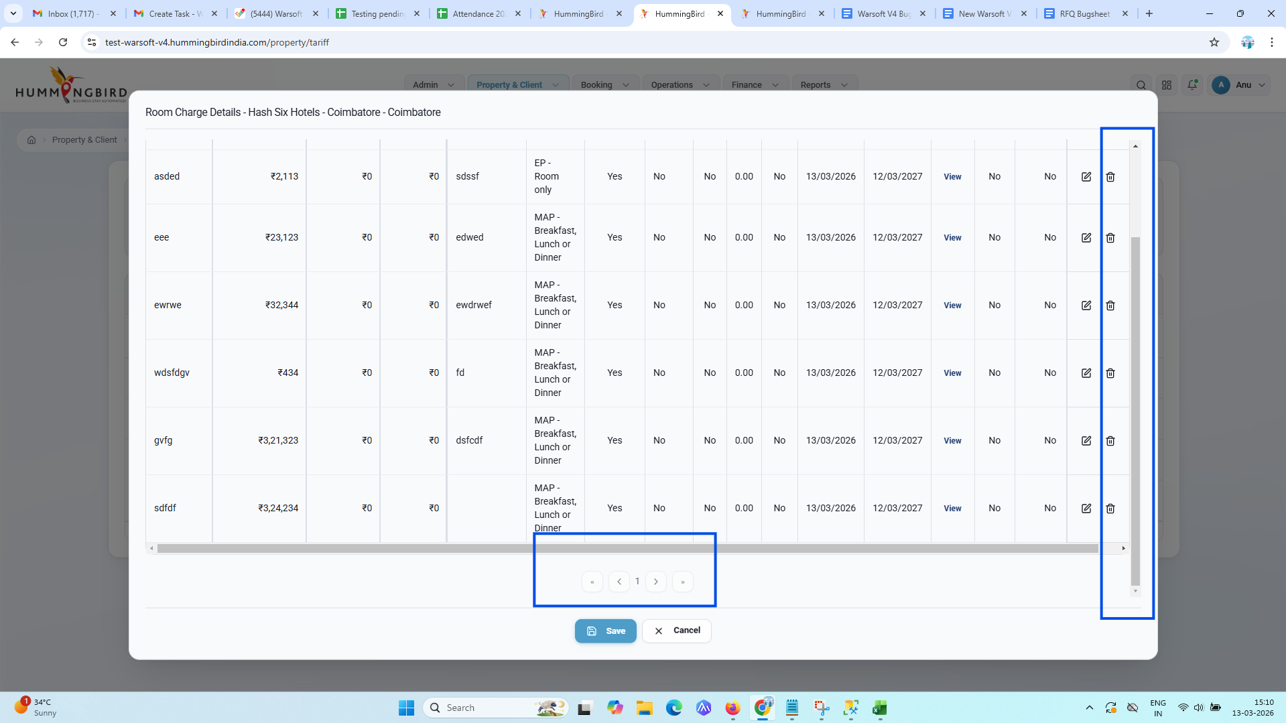

Reference
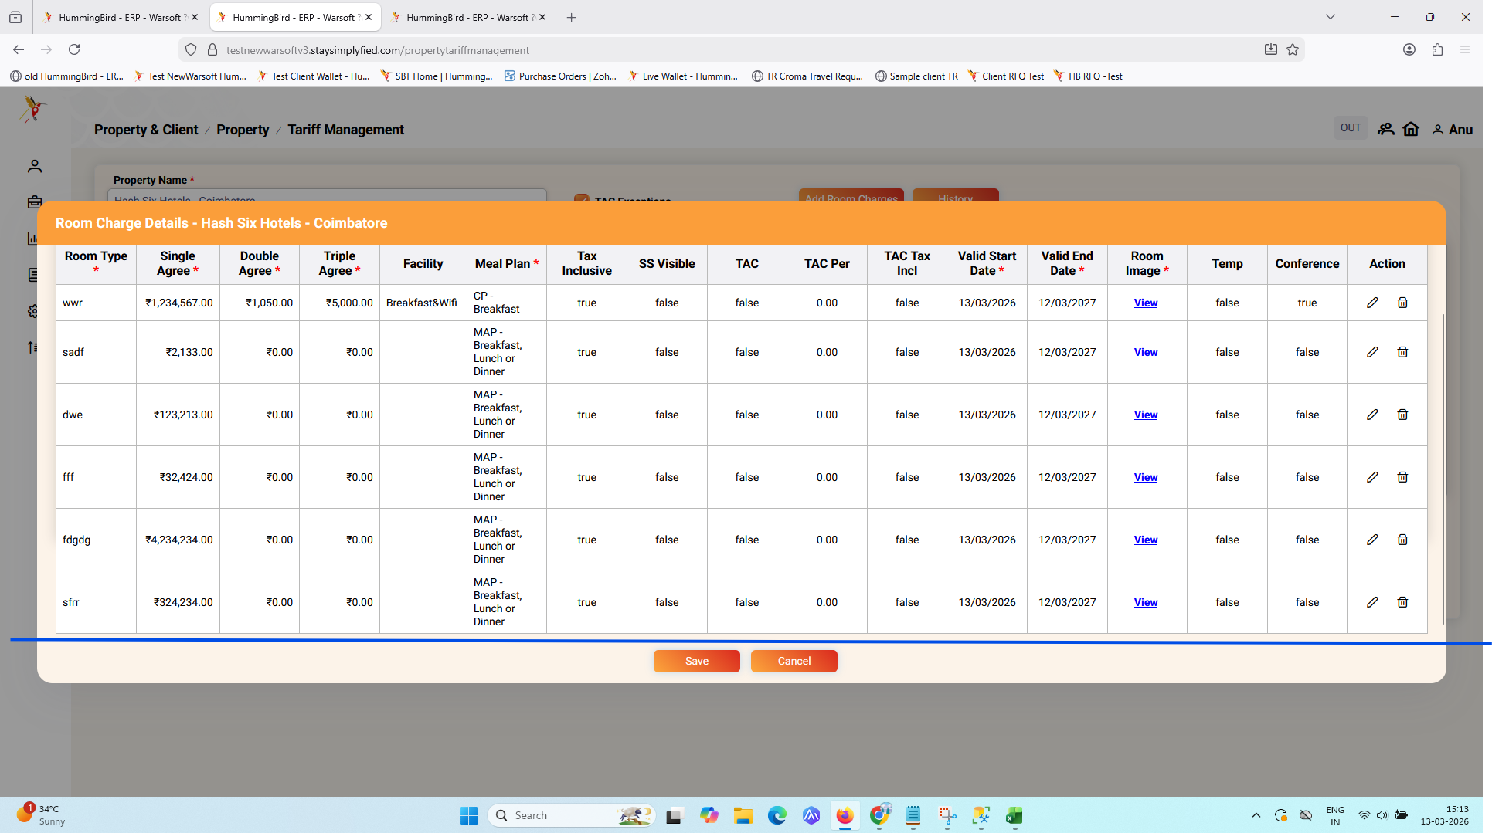

15) TAC Percentage dot not allowing issue
Description-
Entered TAC percentage and clicking on ‘Create’ button
Error message showing like this and while clicking on ‘.’ decimal dot not allowing in the TAC Per field
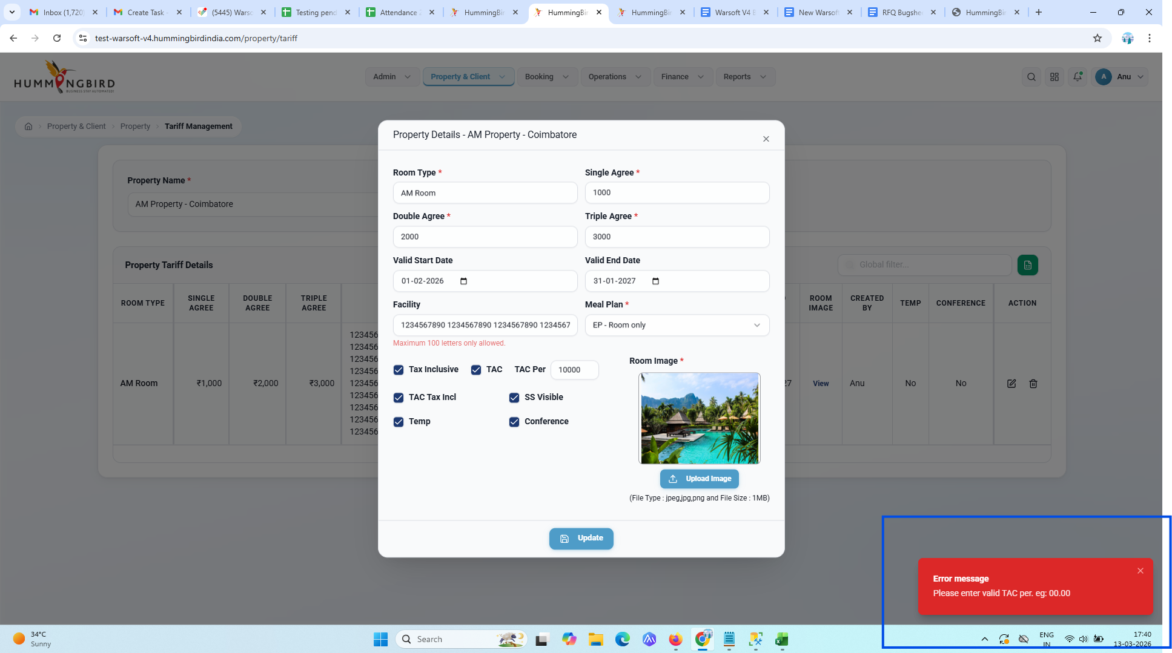

Reference
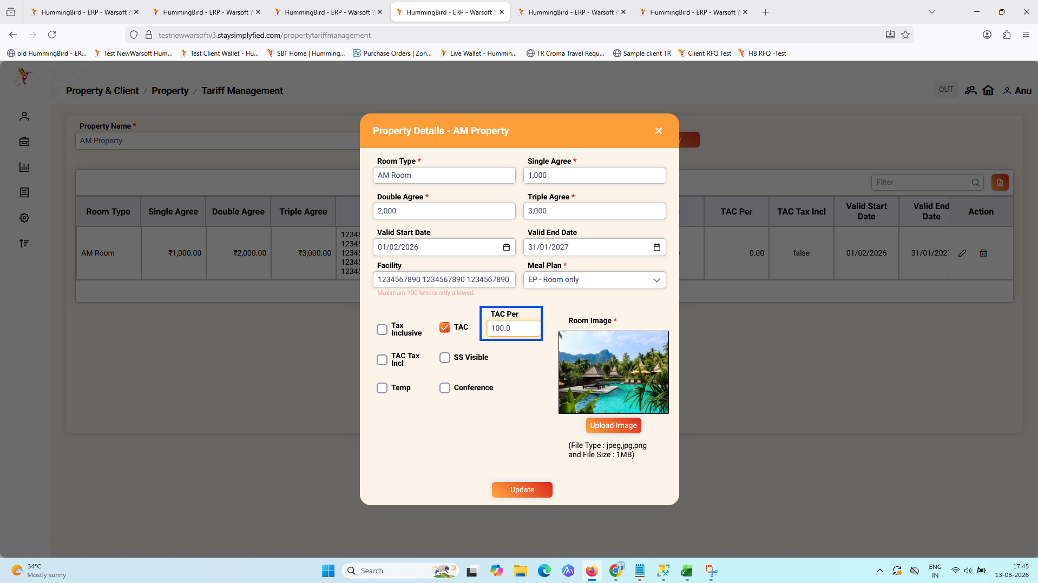

16) date manually allowing to edit
Description-
Date is manually allowing to edit it should not allow to edit or type manually
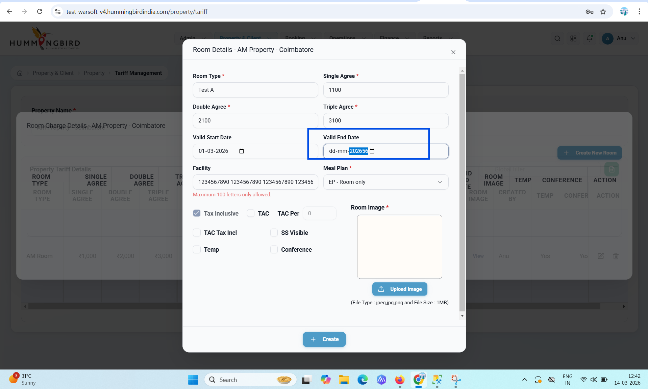
Bugsheet 2 2/4/26

17) Filter not cleared after the property name is selected
Description-
Initially in Filter entered the text and after the property name typed and selected means the filter not cleared.
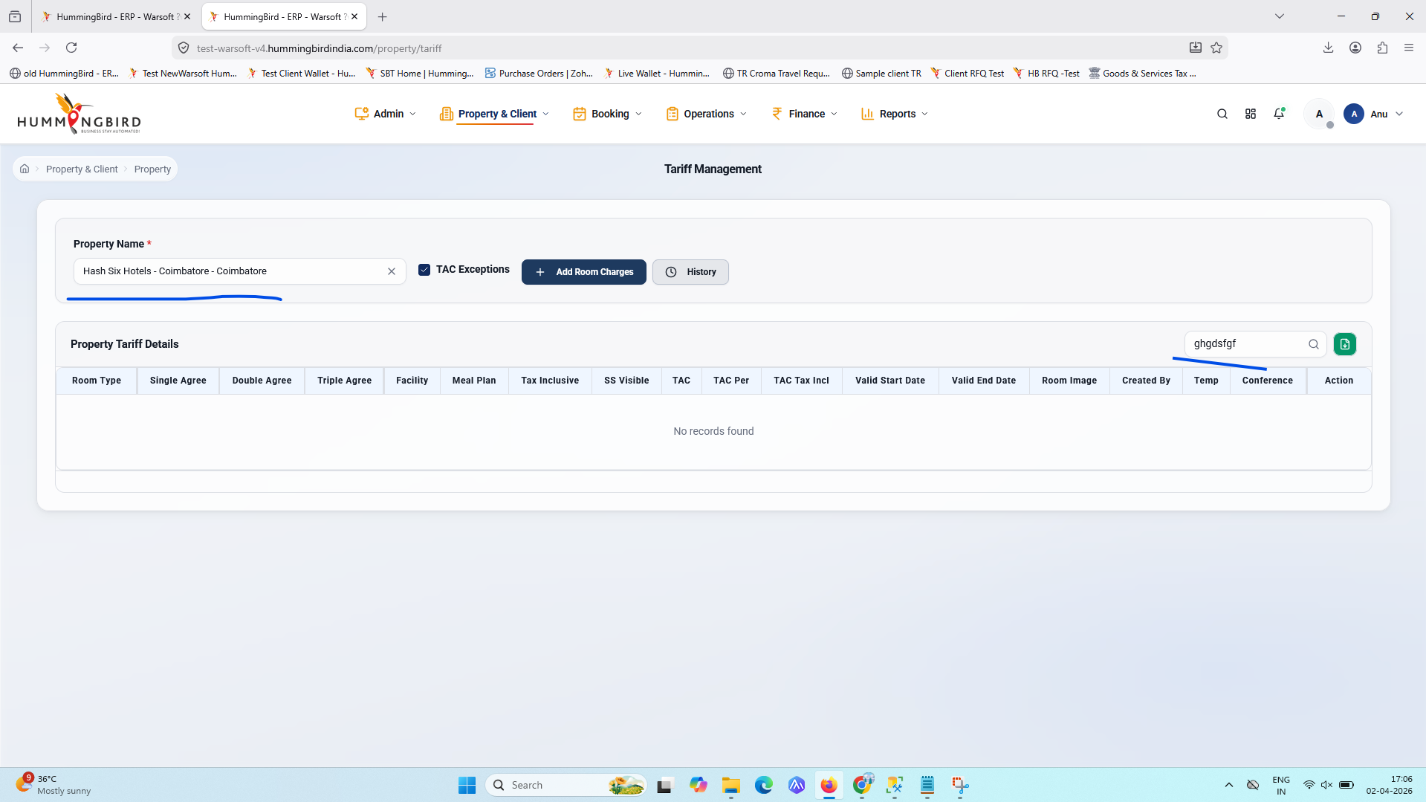

18) Design overlaps
Description-
When horizontal scroll , scrolled from left to right the column heading name is overlapping
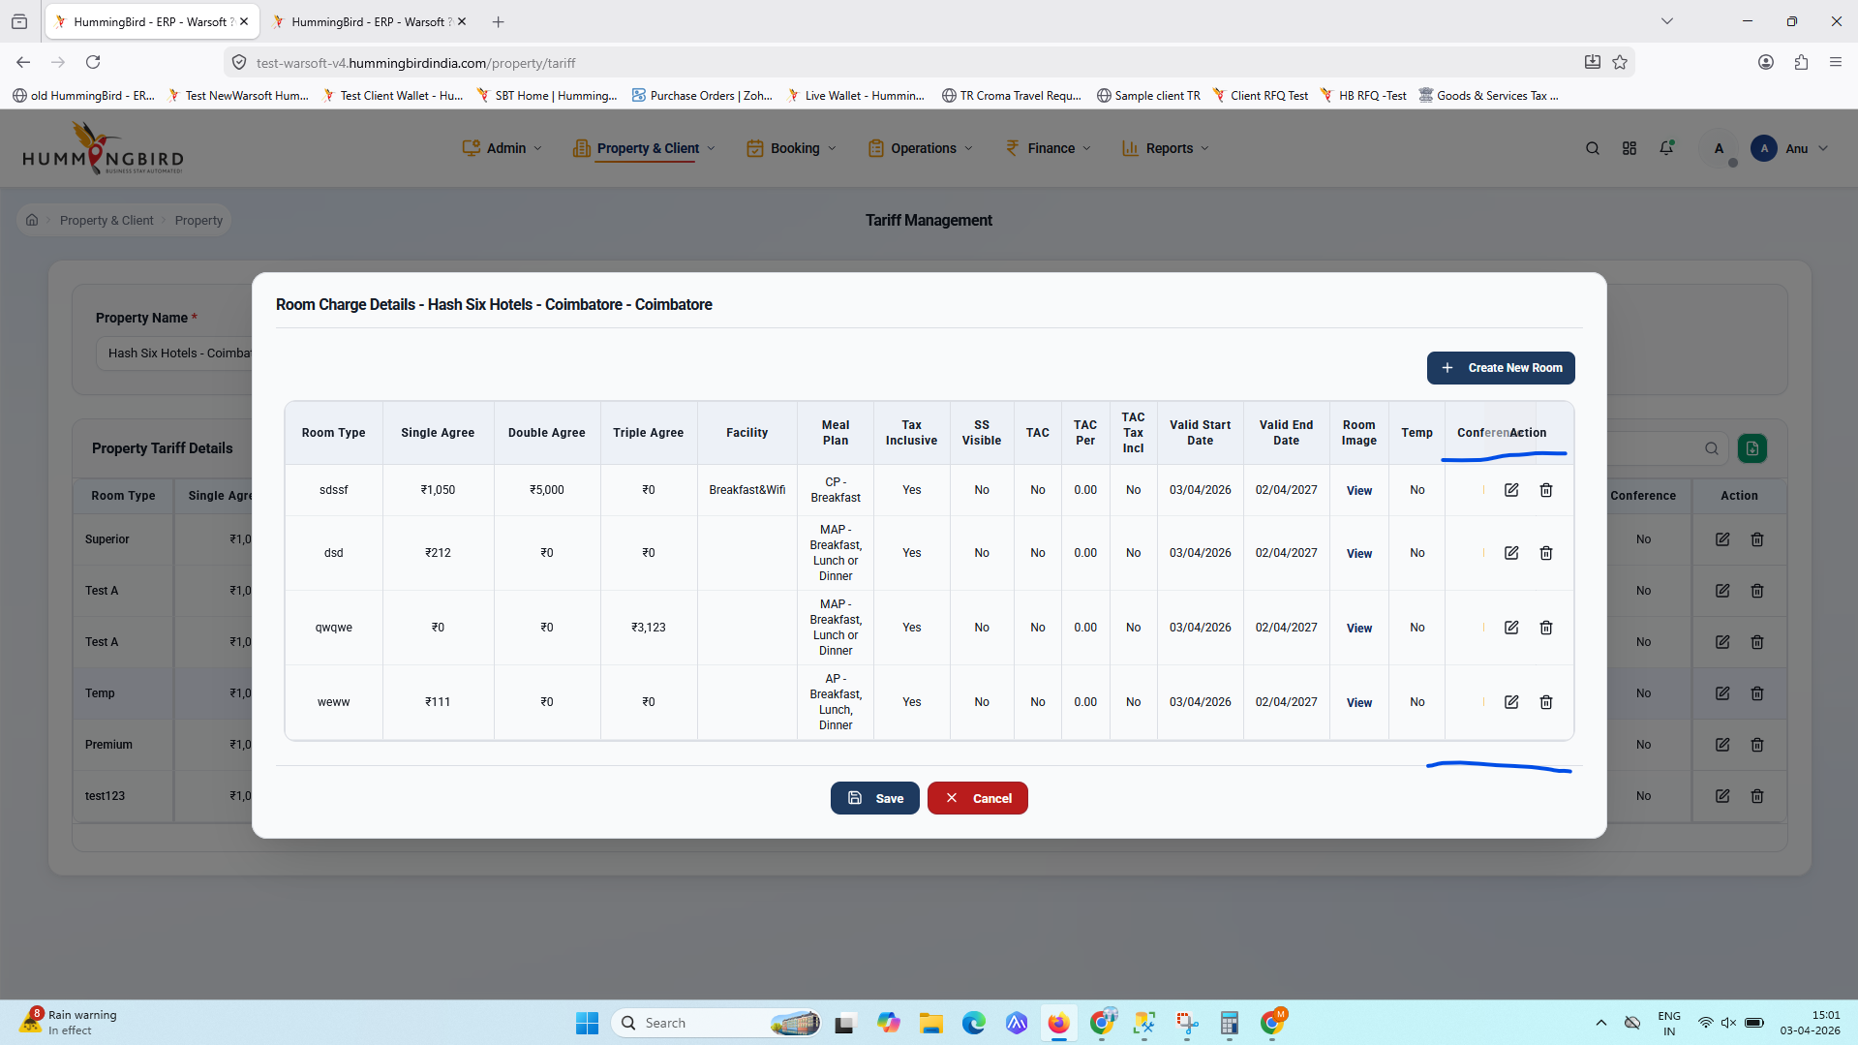

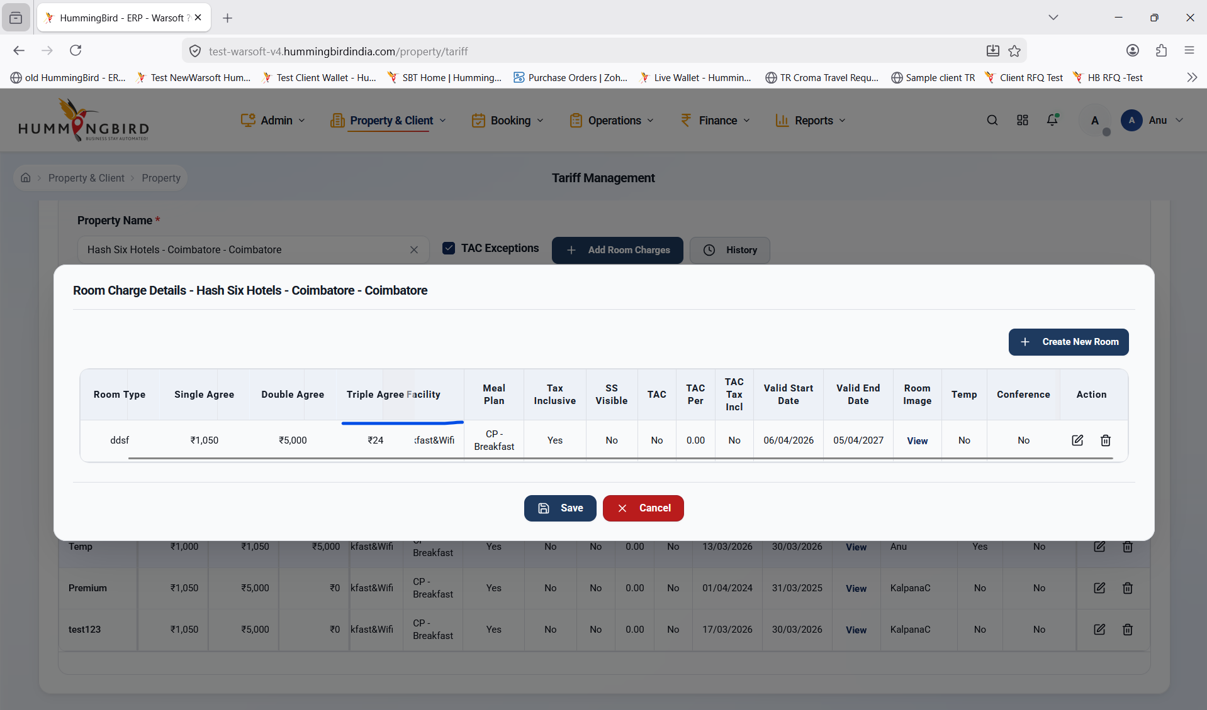

19) Design Issue
Description-
Design issue in Firefox browser
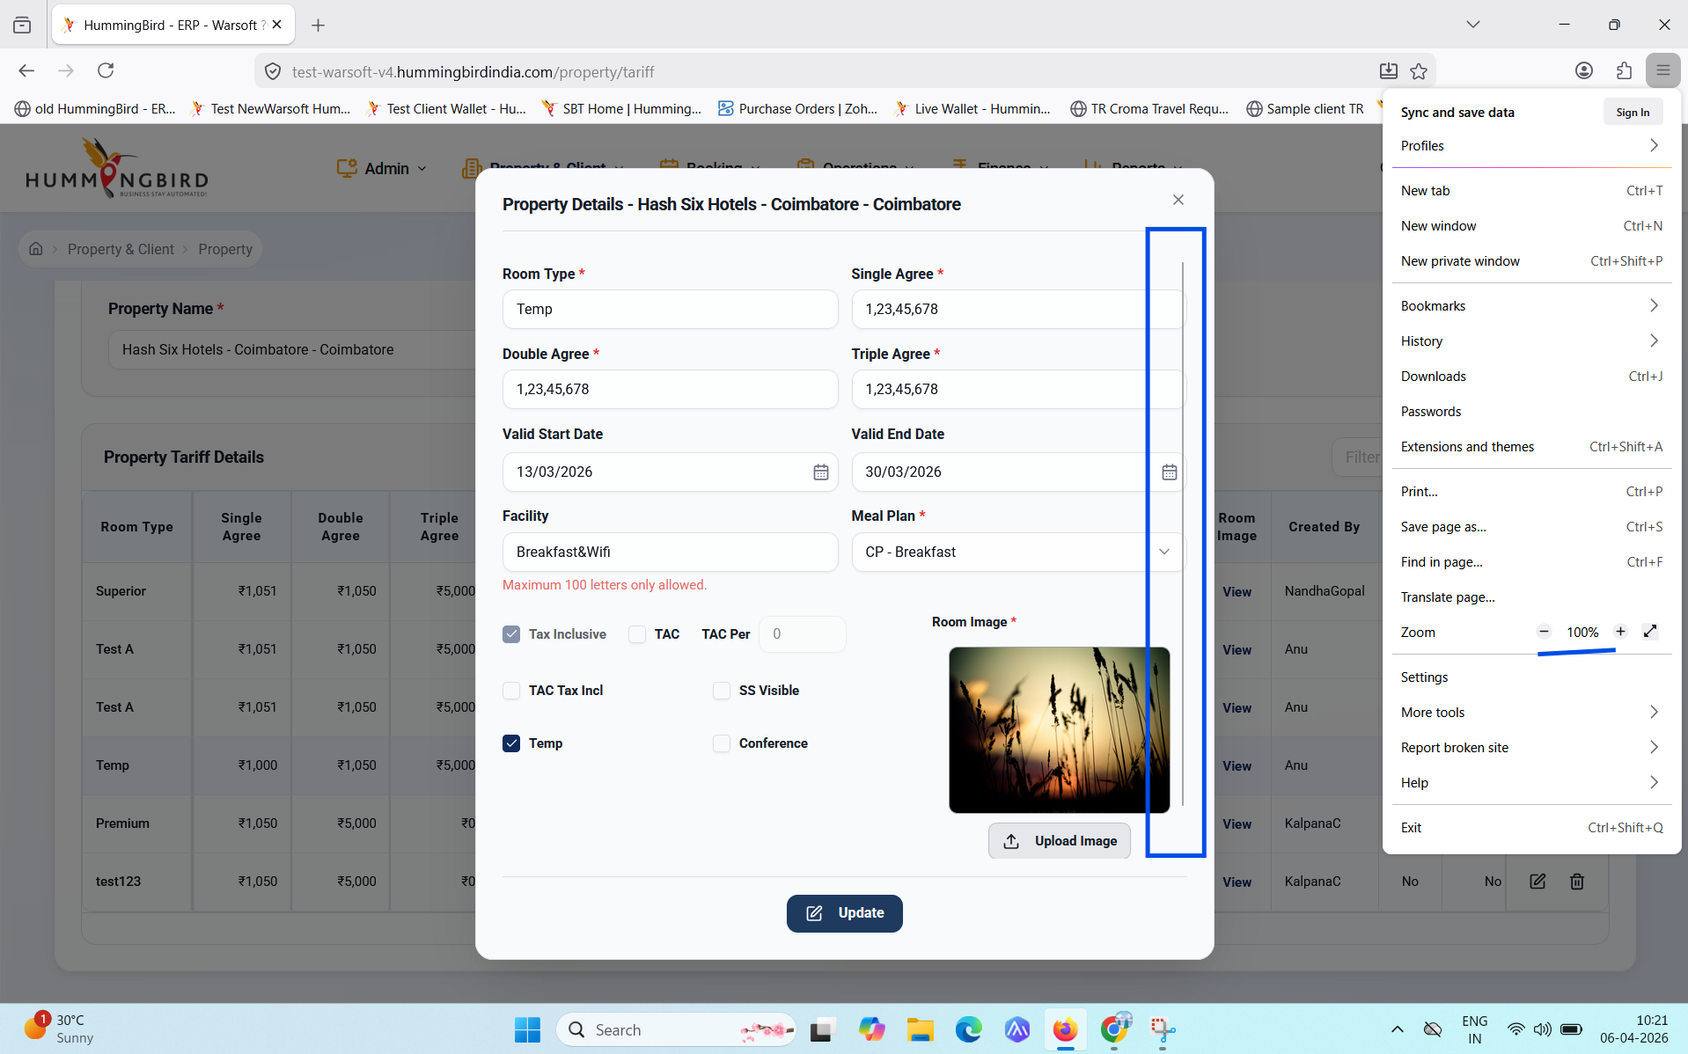

ReTesting 21/9/26

20) Room image upload inside the box - Text issue
Description-
Room image upload, inside the box - there showing Room Text
Image upload issue

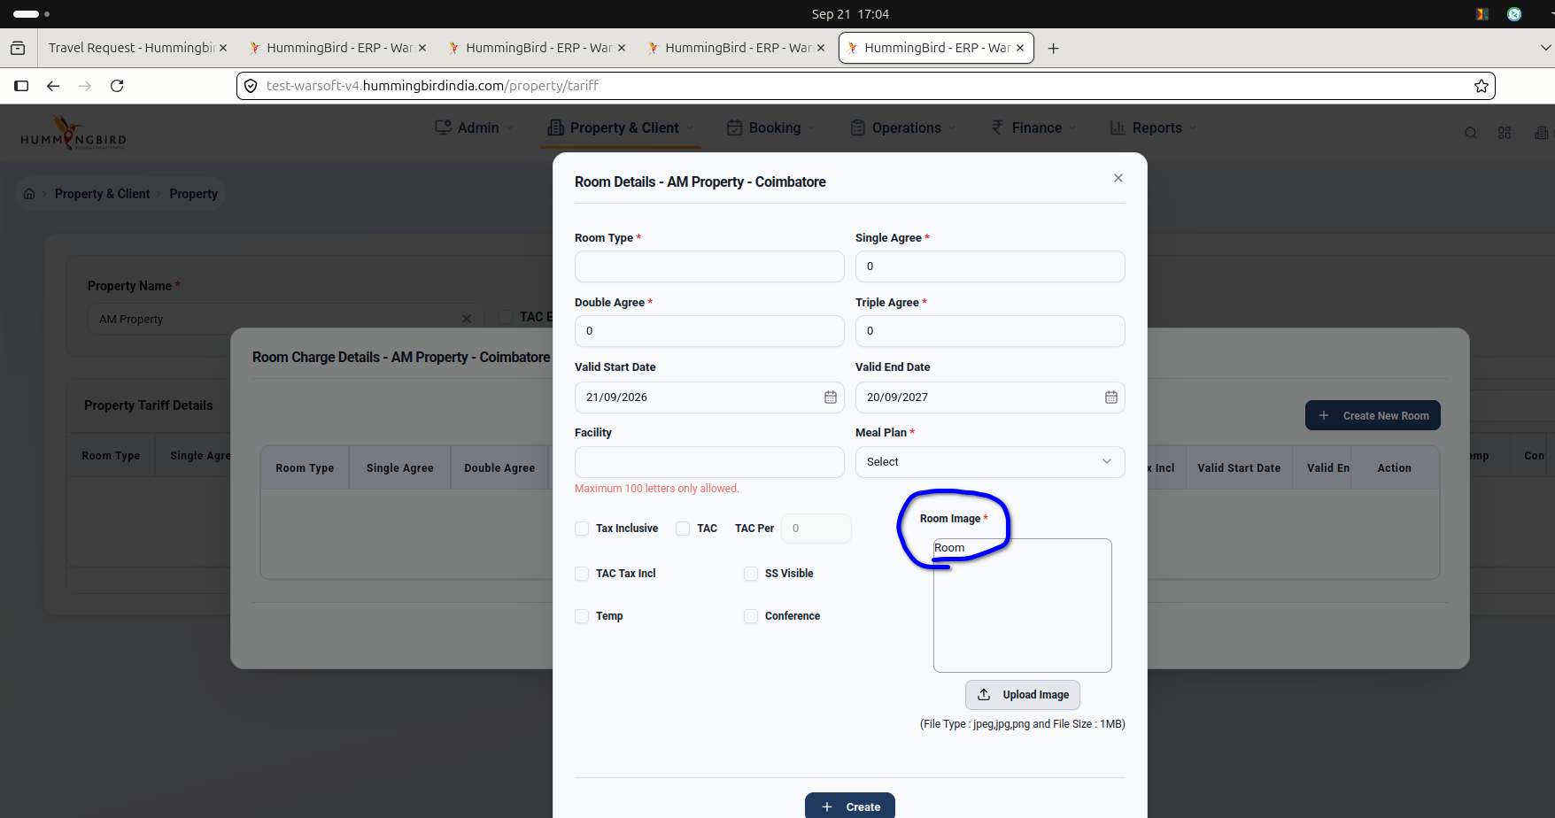

21)
Description-

sample
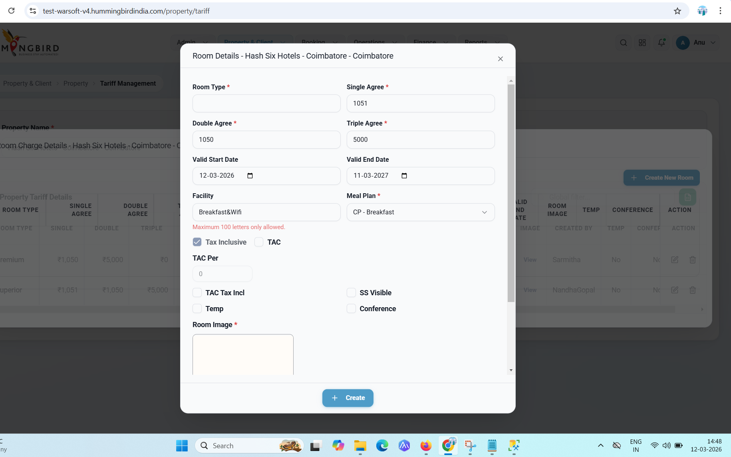
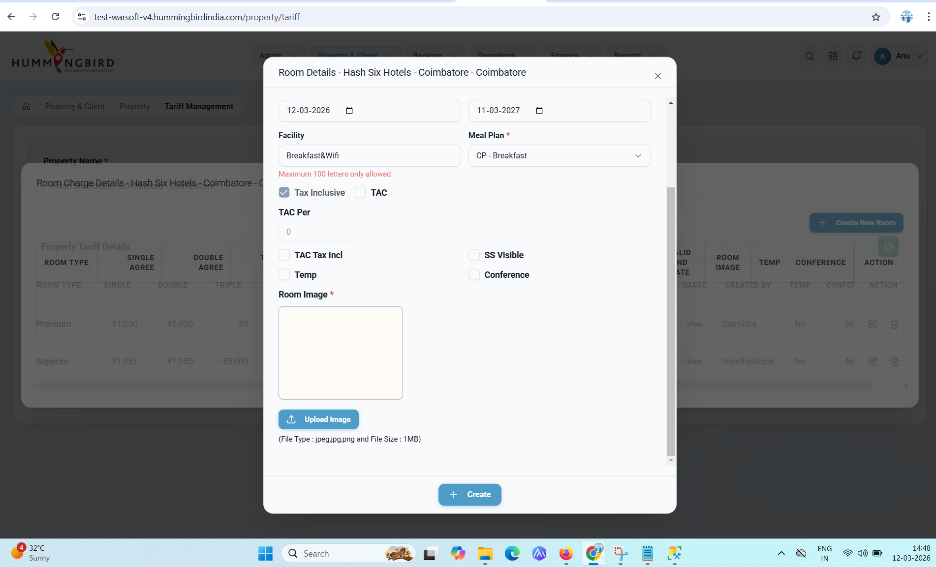

select id, * from WRBHBProperty where PropertyName='AM Property'
select id,* from WRBHBPropertyAgreements where PropertyId=126643
select * from WRBHBPropertyAgreementsRoomCharges where AgreementId in (136998,136999)

